My Story: My Decks
Mike Long
Voodoo II Pro Tour-Tokyo
Main Deck |  | Sideboard
4 Urborg Volcano  9 Mountain  9 Swamp  4 Thunderscape Apprentice  4 Shivan Zombie  4 Pyre Zombie  4 Phyrexian Scuta  4 Skizzik | 4 Scorching Lava  4 Terminate  4 Urza's Rage  4 Ghitu Fire
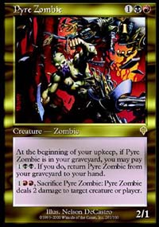
Voodoo II was an attempted cross between the red-black control deck that Dave Williams played in the Top 8 at this event and the red-green deck that dominated the tournament. Though this deck is a neat idea, it just wasn't fast enough to run down control decks and didn't have the staying power to overpower other fast decks. The most glaring mistake was the lack of Flametounge Kavu, and not far behind are the Crypt Angels and Blazing Specters to back the Kavu up. I ended up losing in the final round to Pat Chapin's u-b-r control deck, failing to make Day 2.

Blue Skies Worlds 2000
Main Deck |  | Sideboard
22 Island  4 Spiketail Hatchling  4 Waterfront Bouncer  3 Cloudskate  4 Rishadan Air Ship  3 Drake Hatchling  4 Troublesome Spirit | 4 Thwart  4 Foil  4 Rising Waters  4 Gush
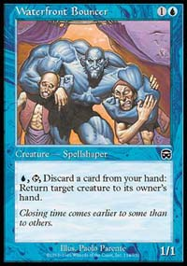
This deck is actually not all that bad. Nicholas Labarre used it to make Top 8 at this World Championship. It is probably the faster beatdown deck in the format, featuring quick creatures and a good amount of counter back-up. I personally struggled understanding the tempo of the deck, not having played either the deck or Masques Block Constructed much beforehand.
This is particularly difficult in MBC because you face some strange cards, like Rebels where, given enough time a 1/1 creature for one mana, the Ramosian Sergent, can single-handedly crush you. It is instead important to put your head down and attack, attack, attack. I got caught too often unwilling to tap out, or when I did, being too nervous to return all my lands to my hand for a Thwart or to lose three cards from my hand to counter a single spell with Foil. In the end I went a paltry 2-4 in this format, earning two more losses than my record could afford to sustain.
Counter-Tinker (Worlds 2000)
Main Deck |  | Sideboard
20 Island  2 Dust Bowl  4 Masticore | 3 Sky Diamond  4 Grim Monolith  4 Voltaic Key  2 Thran Dynamo  4 Daze  4 Counterspell  4 Tinker  4 Thwart  4 Gush  1 Phyrexian Processor
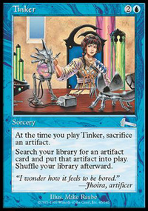
I crossed my "Accelerated Blue" deck with the "Tinker" deck that Jon Finkel would ultimately win Worlds with to create a neat "Counter-Tinker" deck. I was trying to create a more stable version of "Accelerated Blue", and to me stable equals "gets Masticore into play fast". With four Tinkers (I more or less replaced the 4 Treachery from the old version with Tinker; I felt I could no longer rely on my opponent to cast Masticore for me!) and four Masticores I was doubling my chances. This deck also features a lot more artifact mana making it less vulnerable to the Boil-heavy "Ponza" deck that Chris Benafel had come in second at U.S. Nationals with. It was left with only one glaring weakness: Stompy, a deck that I couldn't seem to solve. I decided to put my head down and play the deck anyway, and just hope not to run into the monogreen beatdown deck. Unfortunately I faced it twice, both times resulting in my defeat! Still I beat a conventional "Tinker" deck, "Replenish", "Ponza" and an "Angry Hermit" deck, which represented most of the rest of the field. 4-2 was the best record I'd ever had at worlds in the Standard portion of the event and had always been the format to keep me from making Top 8, so I was fairly satisfied with it.
Fires-White (Chicago 2000)
Main Deck |  | Sideboard
2 Dust Bowl  4 Brushland  3 City of Brass  4 Karplusian Forest  2 Plains  5 Forest  2 Mountain  4 Birds  4 Llanowar Elf  4 Blastoderm | 4 Fires of Yavimaya  4 Chimeric Idol  4 Saproling Burst  2 Assault/Battery  3 Ghitu Fire  3 Aura Mutation  4 Parallax Wave  2 Tsabo's Web | 4 Ramosian Sergeant  2 Defiant Falcon  2 Defiant Vanguard  2 Lin Sivvi, Defiant Hero  1 Jhovall Queen  2 Plains  2 Tsabo's Web
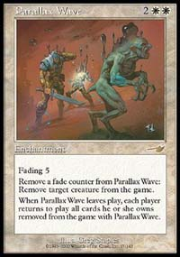
This deck tried to exploit the power of the best cards of what I considered to be the two best decks in the format, "Fires" and "Rebels". Two of the more powerful cards in either deck are Saproling Burst and Parallax Wave, both high cost enchantments. Because of that I opted to play the Mutations straight up, as I thought my opponent would give me several opportunities to get lots of tokens, if not from their enchantments, I could use them on my own. The rebels out of the sideboard gave me a better chance of beating "Counter-Angel" in games two and three than would Boils and Flashfires. They were also good against "Skies" and actually not bad against another "Fires" deck or even "Rebels".

Accelerated Blue (USN 2000)
Main Deck |  | Sideboard
4 Rishadan Port  18 Island  4 Masticore  4 Morphling  1 Palinchron | 4 Brainstorm  4 Grim Monolith  4 Counterspell  4 Rewind  2 Thwart  2 Stroke of Genius  1 Opportunity  4 Powder Keg  4 Treachery
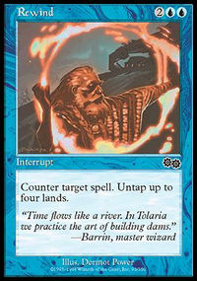
Zvi first introduced me to this deck at the Magic Invitational in Kuala Lumpur. Since I don't spend very much time on the internet at all I missed out on decks that were being played in smaller local tournaments all the time. I did however catch an old Grudge Match report by Alex Shvartsman featuring this deck, so I put it together and it worked well for me. I adjusted a card or two and decided to play it at Nationals.
It is a really neat deck, and I think this is what Wizards probably had in mind when they made Grim Monolith. Between Treachery and Rewind, the Monolith is becomes a really nifty card, not to mention how good it is at letting you get down a quick Masticore, Morphling or even Palinchron while still allowing you to protect it!
I decided to go a little light on counter-power, playing only ten counters, opting instead to play a lot of creature control. This turned out great, as I relied on players assuming I had counters a plenty and not casting crucial spells until they thought they had the ability to force it into play. Often times that gave me the time to act first, by getting a big threat into play or by drawing a ton of cards with a Stroke or Opportunity. One note is that I often played a Port and then didn't use it during my opponent's upkeep whether I needed the mana or not, creating the illusion that I had some sort of counter in my hand.

